[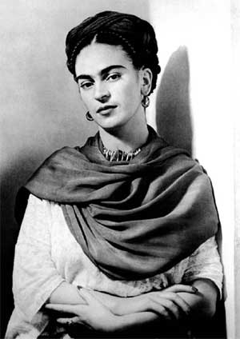](http://www.tate.org.uk/modern/exhibitions/kahlo/images/guide_rm9.jpg)[](http://images.indiebound.com/028/984/9780810984028.jpg)

[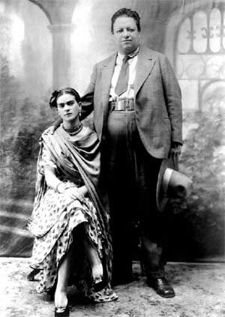](http://www.riveraexperts.com/bio/images/31%20Wedding%20Photo%20of%20Diego%20Rivera%20and%20Frida%20Kahlo%2021%20August%201929.jpg)

[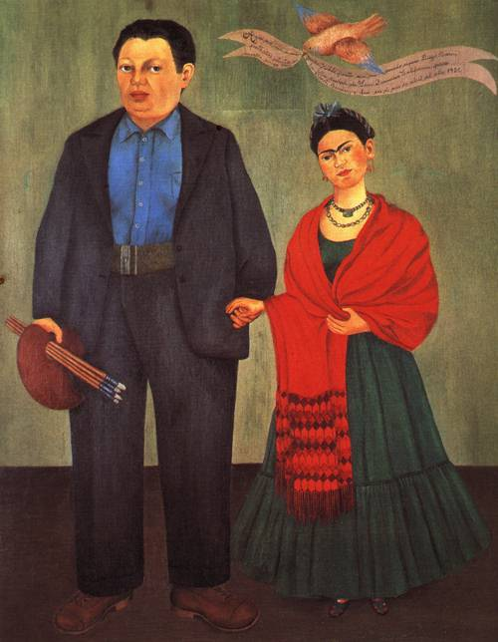](http://www.oceansbridge.com/paintings/artists/k/frida-kahlo/big/frieda-kahlo-and-diego-rivera-1931.jpg)

***Frieda and Diego***

[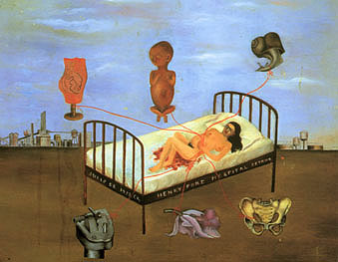](http://www.reproduction-gallery.com/oil_painting_reproduction_gallery/Frida-Kahlo-Henry-Ford-Hospital-1932-large-1022579162.jpg)

***Henry Ford Hospital*** (1932)

[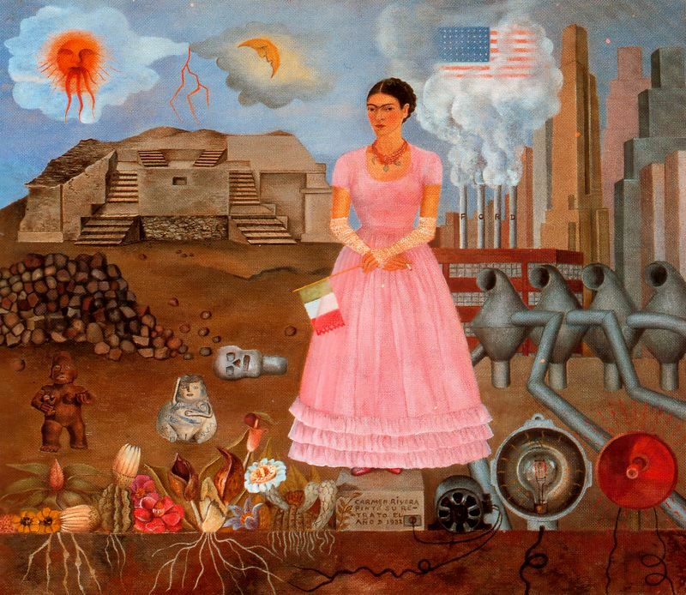](http://www.artwallpapers.org/paintings/Frida-Kahlo/images/Frida%20Kahlo%20Painting%2018.jpg)

**Self-Portrait on the Borderline Between Mexico and the United States** (1932)

[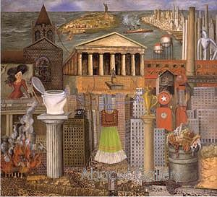](http://www.abacus-gallery.com/shopinfo/uploads/1132566588_large-image_1038572754_largeimage_fkdresstherelg.jpg)

**My Dress Hangs Here (1933)**

[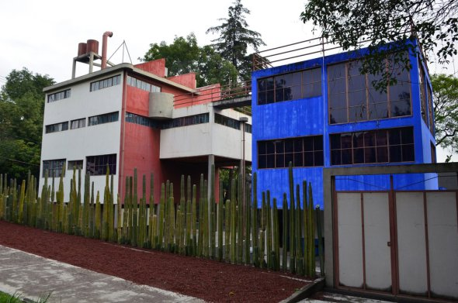](http://www.imer.mx/rmi/treinta-y-cuatro-anos-recordando-a-juan-ogorman/)

**House/Studio in San Angel**

[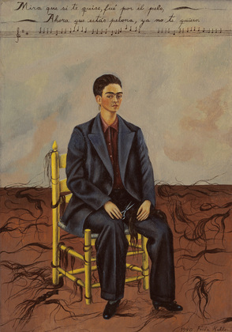](http://www.moma.org/collection_images/resized/317/w500h420/CRI_151317.jpg)

**Self- Portrait with Cropped Hair (1940)**

[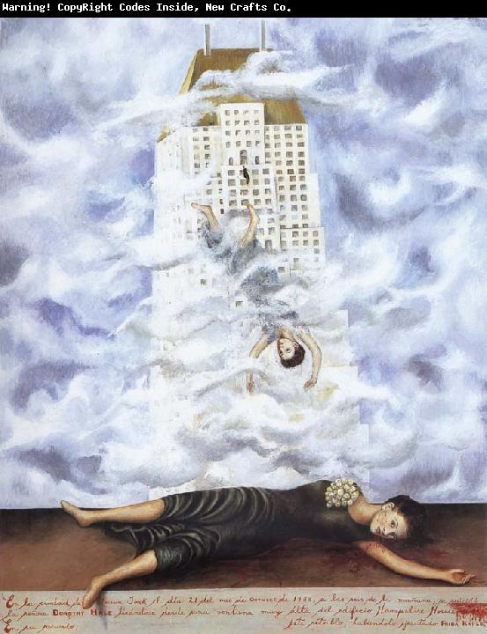](http://www.xiamenoilpainting.com/upload1/file-admin/images/new10/Frida%20Kahlo-872592.jpg)

**The Suicide of Dorothy Hale (1939)**

[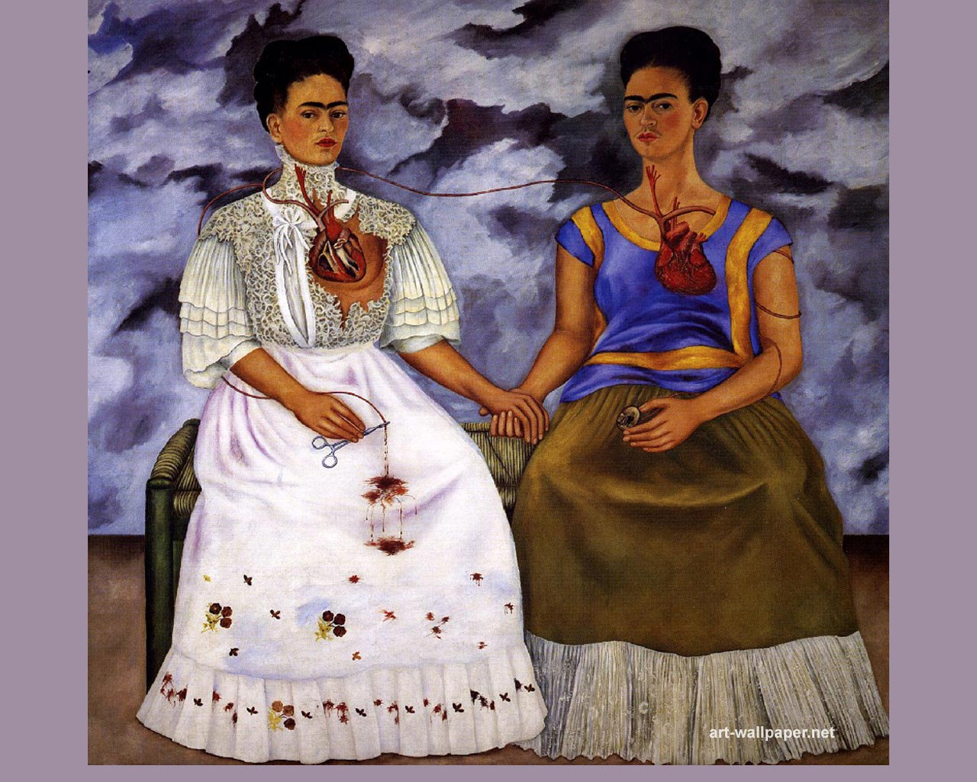](http://www.art-wallpaper.net/artist/frida-kahlo/03/Frida-Kahlow.jpg) **The Two Fridas (1939)**

[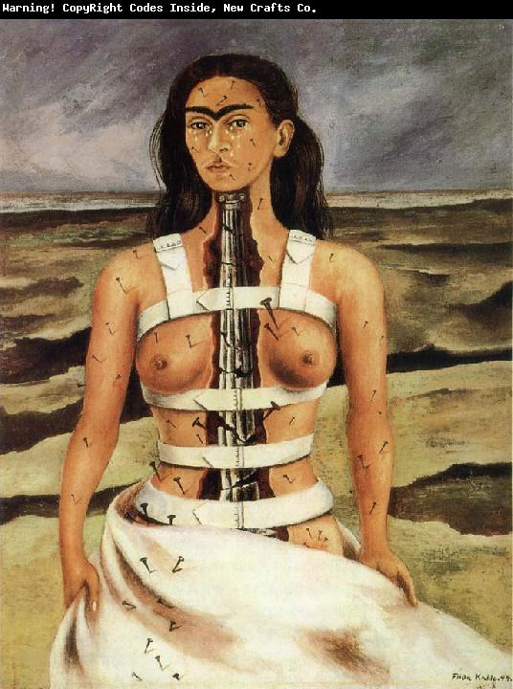](http://www.xiamenoilpainting.com/upload1/file-admin/images/new11/Frida%20Kahlo-293838.jpg)

**The Broken Column (1944)**

[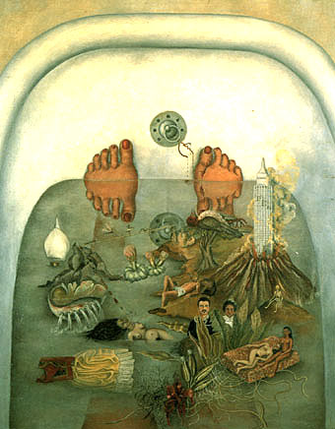](http://www.artinternationalwholesale.com/artwholesale/images/Art/Kahlo/Reproduction-oil-paintings-Frida-Kahlo04.jpg)

**What the Water Gave Me (1938)**

[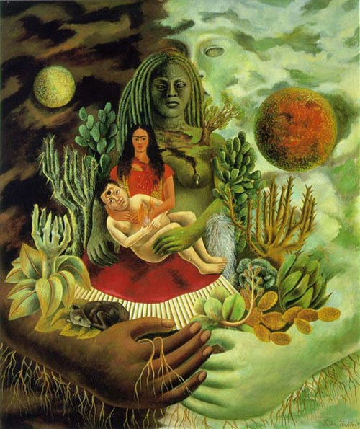](http://www.mexicolore.co.uk/images-1/153_03_2.jpg)

**The Love Embrace of the Universe, The Earth (Mexico), Diego, Me, and Señor Xólotl (1949)**

[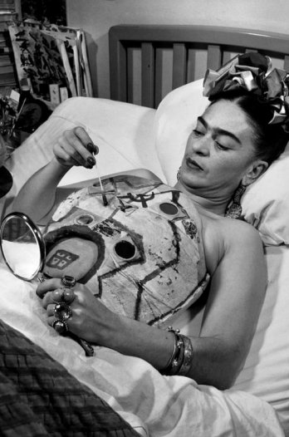](http://dataliteracy.files.wordpress.com/2012/01/frida-kahlo-painting-her-corset.jpg)[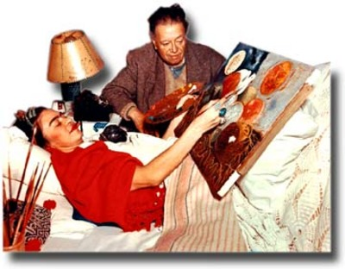](http://leavingevidence.files.wordpress.com/2010/07/frida-khalo-bed-painting.jpg)

[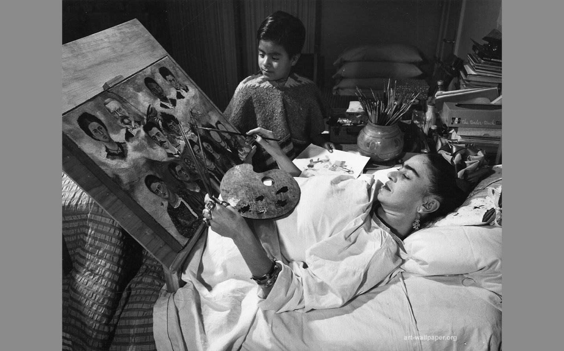](http://www.arts-wallpapers.com/art-wallpaper-org/Artist-Wallpaper/Frida-Kahlo/04/Frida-Kahlo-hd16801050.jpg)

[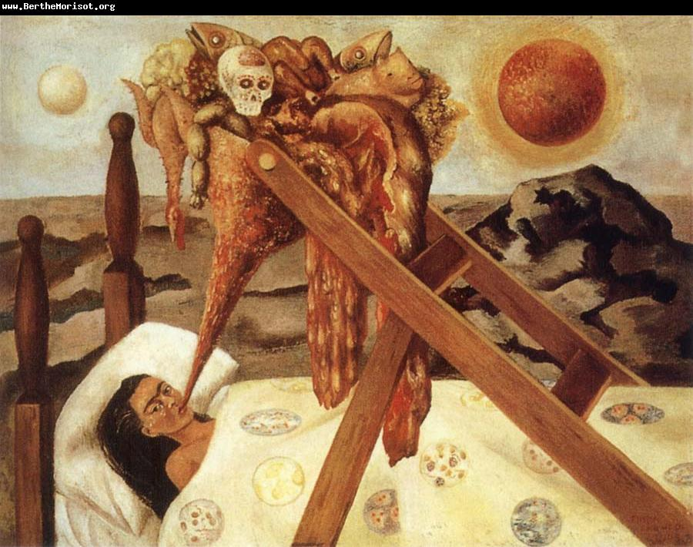](http://www.berthemorisot.org/upload1/file-admin/images/new11/Frida%20Kahlo-565585.jpg)

**Without Hope (1945)**

[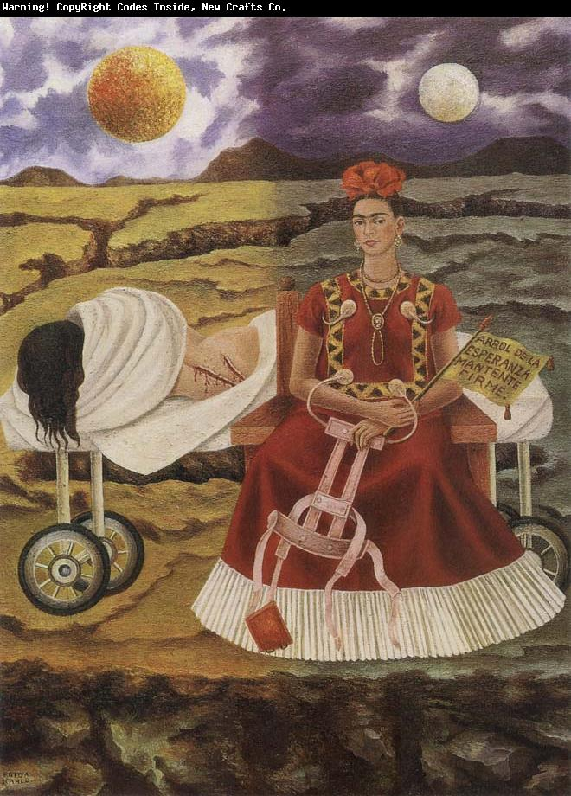](http://www.chinafineart.com/upload1/file-admin/images/new11/Frida%20Kahlo-899234.jpg)

**Tree of Hope (1946)**

[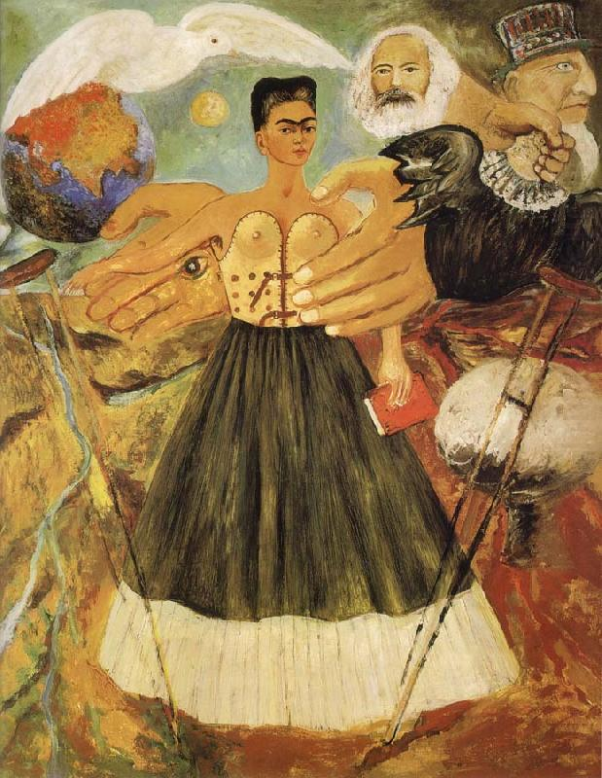](http://www.chinaoilpainting.com/upload1/file-admin/images/new11/Frida%20Kahlo-596879.jpg)

**Marxism Will Give Health to the Sick (1953-1954)**

[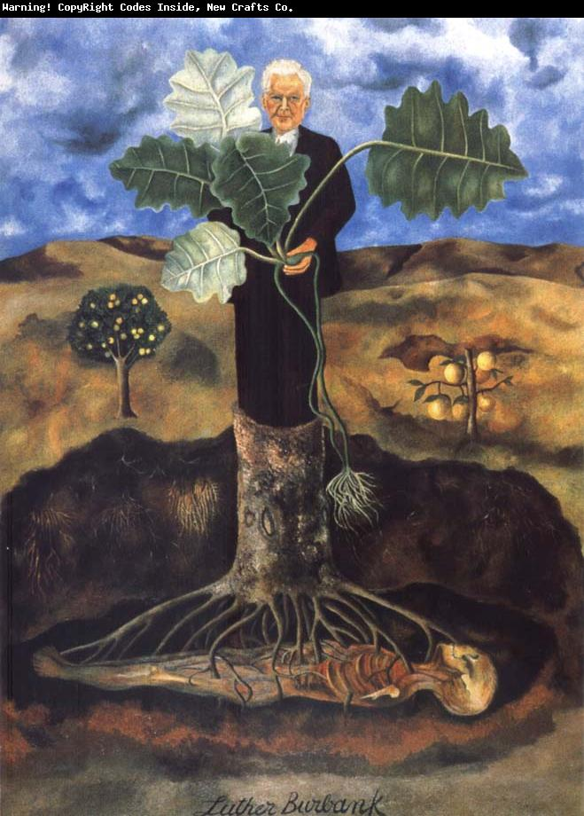](http://www.oilpainting-frame.com/upload1/file-admin/images/new10/Frida%20Kahlo-272339.jpg)

**Luther Burbank (1931)**

[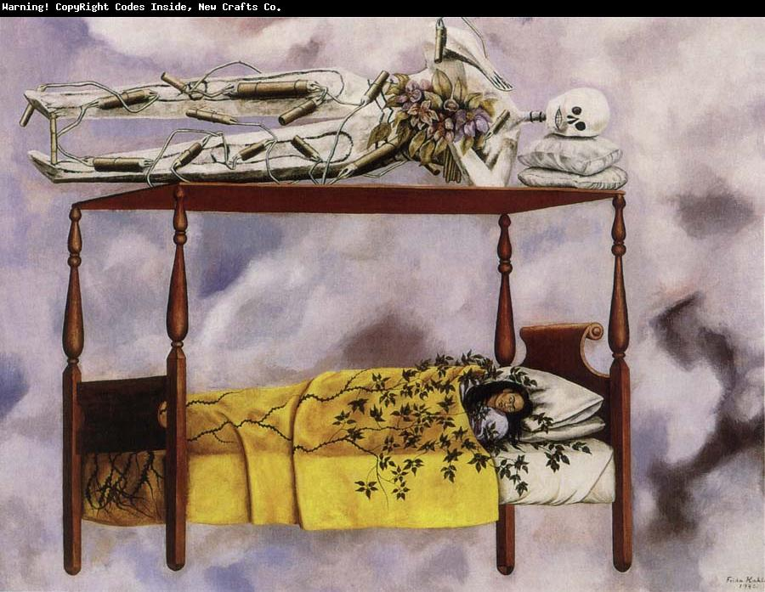](http://www.chinafineart.com/upload1/file-admin/images/new11/Frida%20Kahlo-228497.jpg)

**The Dream (1940)**

[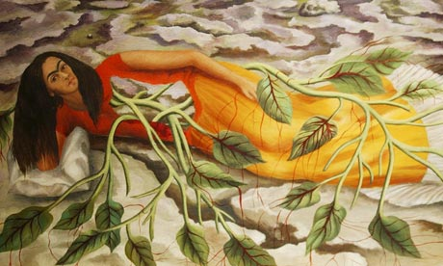](http://static.guim.co.uk/sys-images/Guardian/Pix/pictures/2010/7/6/1278421497886/Frida-Kahlo-006.jpg)

**Roots (1943)**

[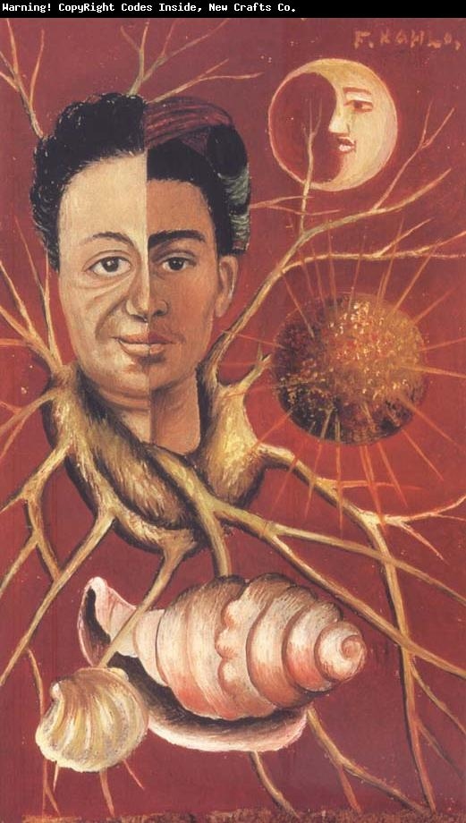](http://www.wholesalechinaoilpainting.com/upload1/file-admin/images/new10/Frida%20Kahlo-959282.jpg)

**Diego and Frida**

[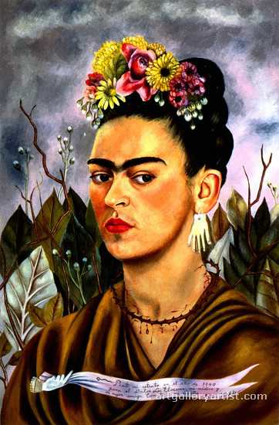](http://www.artgalleryartist.com/frida-kahlo/paintings/images/aga-frida_kahlo8130kioy862.jpg)

[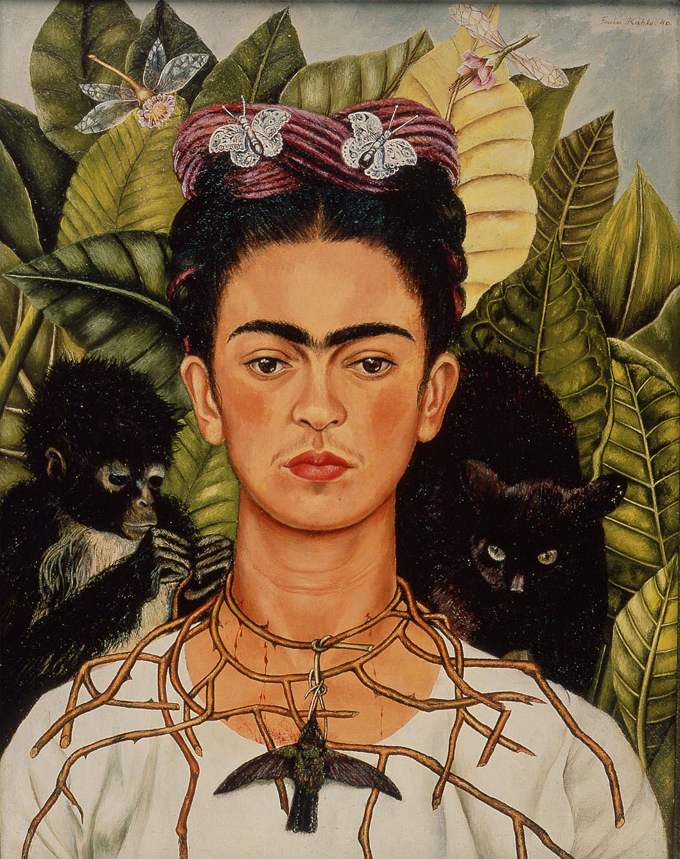](http://www.rachelgoede.com/blog/wp-content/uploads/2010/10/Frida_Kahlo_Self_Portrait_300dpi1.jpg)

**Self-Portrait with Thorny Necklace (1940)**

[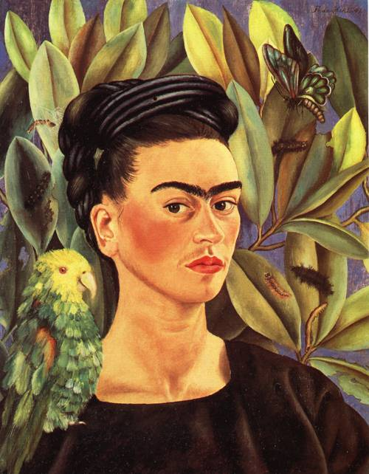](http://www.oceansbridge.com/paintings/artists/k/frida-kahlo/big/self-portrait-with-bonito-1941-xx-private-collection.jpg)

Self-Portrait Dedicated to Sigmund Firestone (1940)

[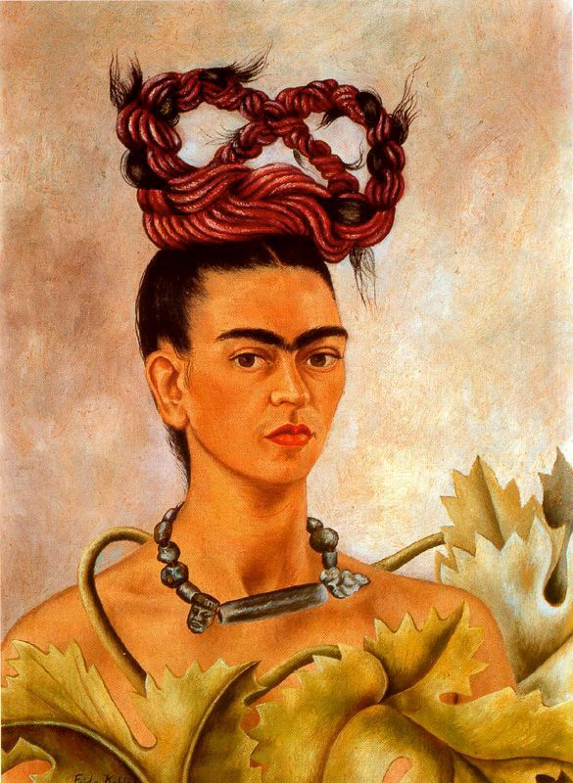](http://www.artwallpapers.org/paintings/Frida-Kahlo/images/Frida%20Kahlo%20Painting%2068.jpg)

**Self-Portrait with Braid (1941)** [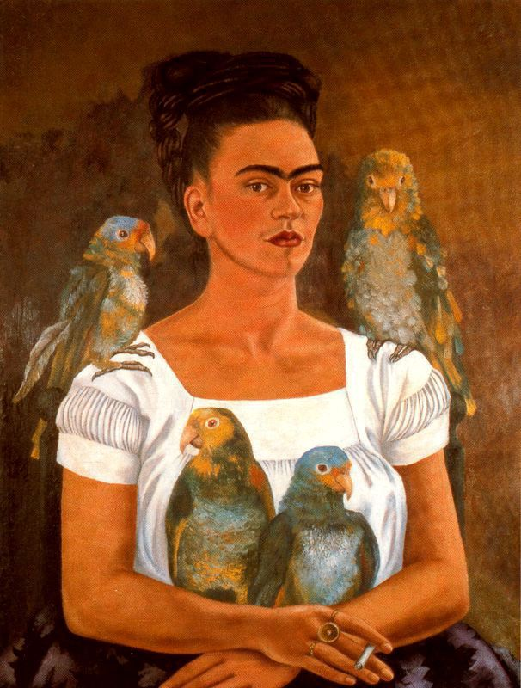](http://www.artwallpapers.org/paintings/Frida-Kahlo/images/Frida%20Kahlo%20Painting%2006.jpg)

**Me and My Parrots (1941)**

[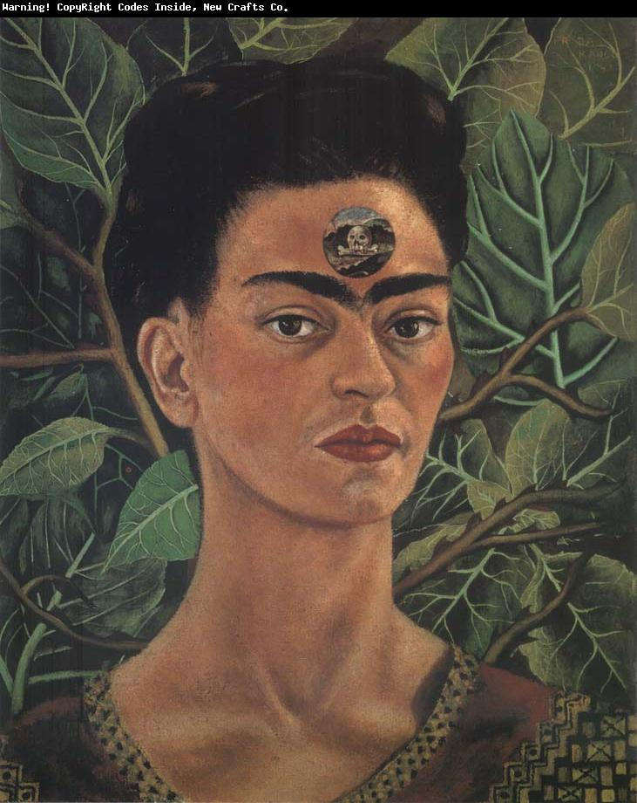](http://www.wholesalechinaoilpainting.com/upload1/file-admin/images/new10/Frida%20Kahlo-547689.jpg)

**Diego in My Thoughts (1943)**

[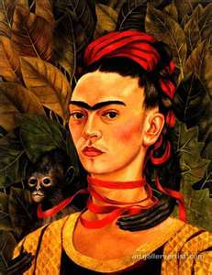](http://www.bing.com/images/search?q=frida+kahlo+painting+images&view=detail&id=E171451ADD25BF3B5FE9D38D29E3D76412198133&first=61&FORM=IDFRIR)

[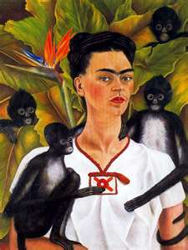](http://www.bing.com/images/search?q=frida+kahlo+painting+images&view=detail&id=ADC81252AF86C6AEAC912657562FB349D6218487&first=0&qpvt=frida+kahlo+painting+images&FORM=IDFRIR)

**Self-Portrait with Monkeys (1943)**

[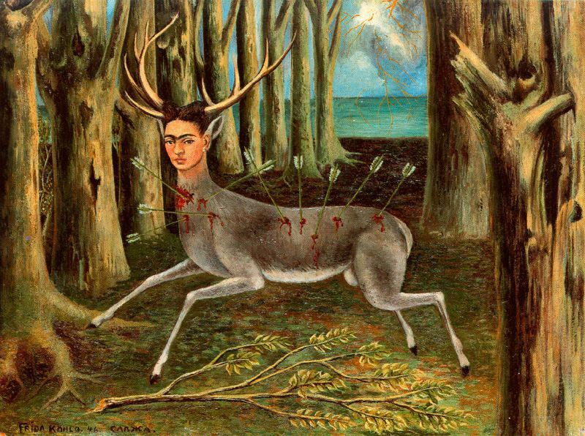](http://www.artwallpapers.org/paintings/Frida-Kahlo/images/Frida%20Kahlo%20Painting%2002.jpg)

**The Little Deer (1946)**

[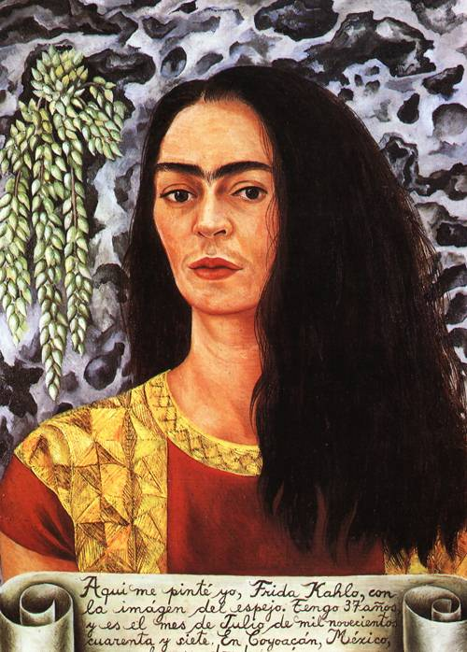](http://www.oceansbridge.com/paintings/artists/k/frida-kahlo/big/self-portrait-with-loose-hair-1947-xx-private-collection.jpg)

**Self-Portrait with Loose Hair (1947)**

[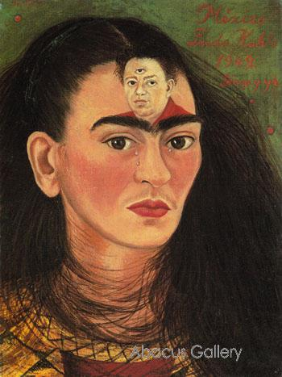](http://www.abacus-gallery.com/shopinfo/uploads/1283835066_large-image_frida_kahlo_diego_and_i_1949_027_oil_painting_large.jpg)

Diego and I (1949)

[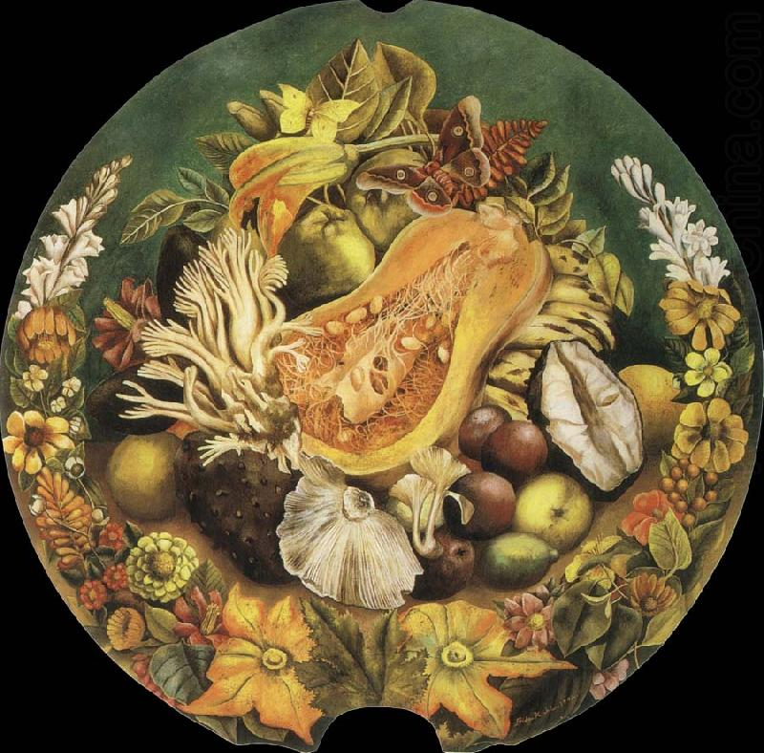](http://www.fineart-china.com/upload1/file-admin/images/new11/Frida%20Kahlo-837987.jpg)

**Still Life (1942)**

[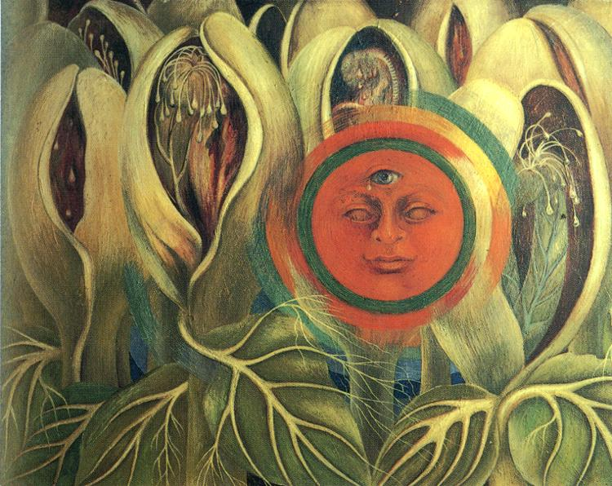](http://www.friendsofart.net/static/images/art2/frida-kahlo-sun-and-life.jpg)

[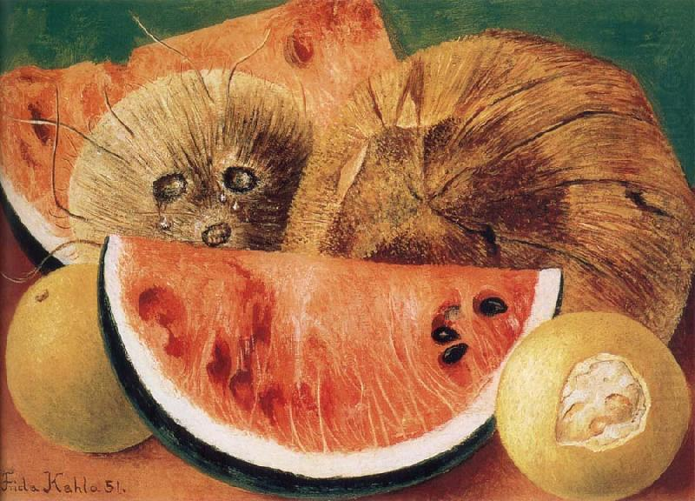](http://www.chinaoilpainting.com/upload1/file-admin/images/new11/Frida%20Kahlo-872787.jpg)

**Coconuts (1951)**

[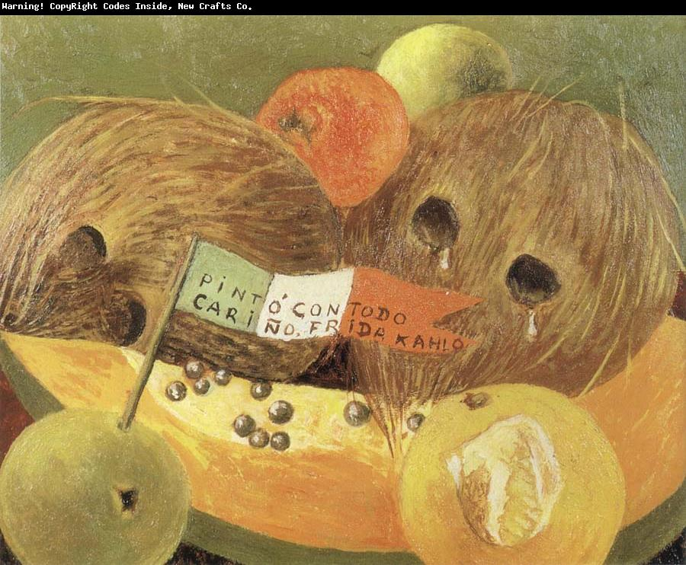](http://www.wholesalechinaoilpainting.com/upload1/file-admin/images/new11/Frida%20Kahlo-428569.jpg)

Coconut Tears (1951)

[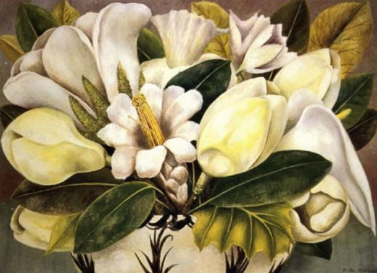](http://www.oilpaintings-sales.com/images-big/frida-kahlo/frida-kahlo-magnolias-80609.jpg)

[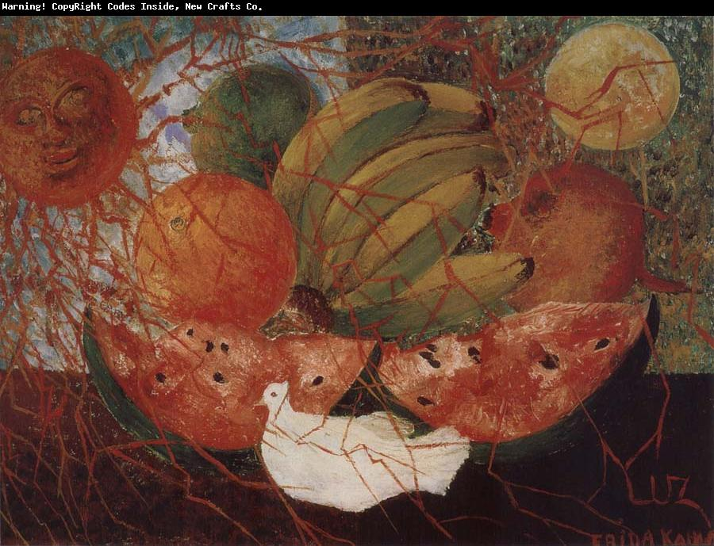](http://www.wholesalechinaoilpainting.com/upload1/file-admin/images/new11/Frida%20Kahlo-666347.jpg)

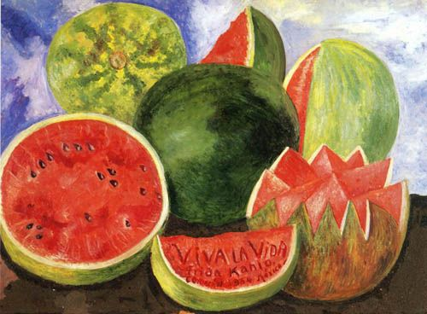

**Viva la Vida (1954)**

[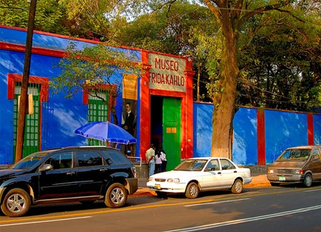](http://www.serturista.com/wp-content/uploads/2007/09/frida-kahlo-casa-azul.jpg)

[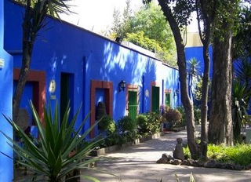](http://bicentenario.com.mx/wp-content/uploads/2011/04/casa.jpeg)

[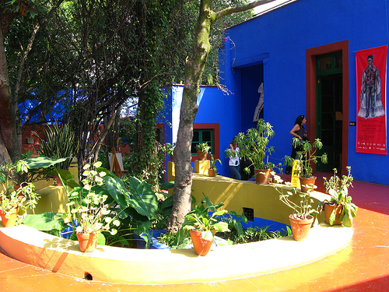](http://termometroturistico.es/files/2009/11/museo-frida-kahlo.jpg)

[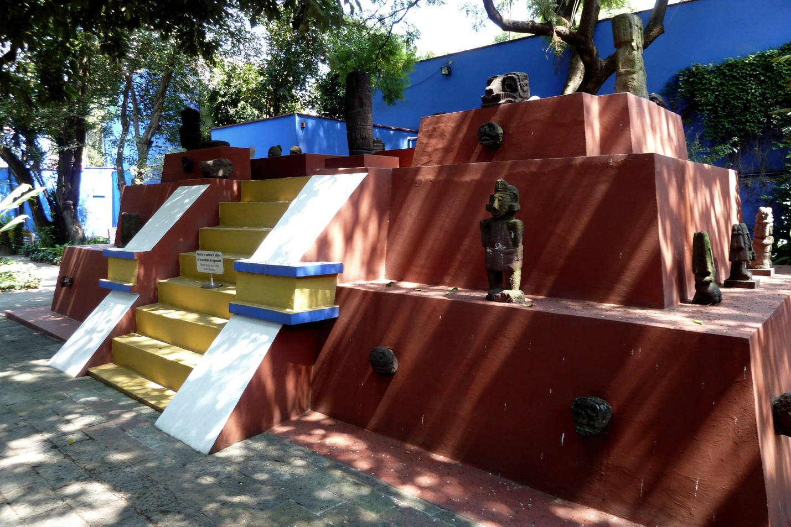](http://static.panoramio.com/photos/original/43194389.jpg)

[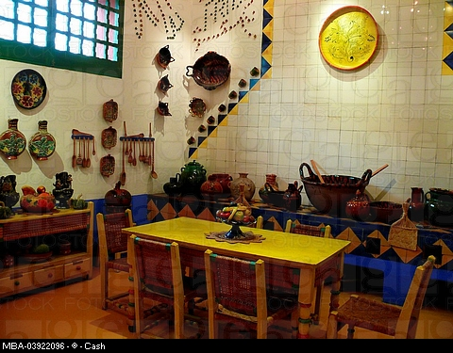](http://download.agefotostock.com/fotos/bajaage/cached/2625/MBA-03922096.jpg)

[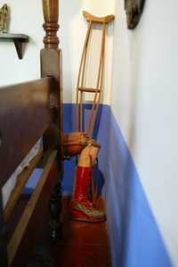](http://www.jornada.unam.mx/2007/07/05/fotos/a04n1cul-1_mini.jpg)

[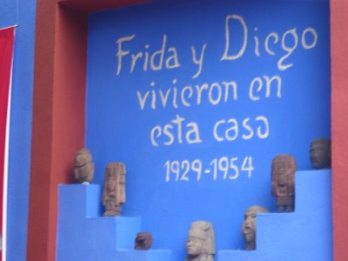](http://sobreturismo.es/wp-content/uploads/casa-azul2.jpg)